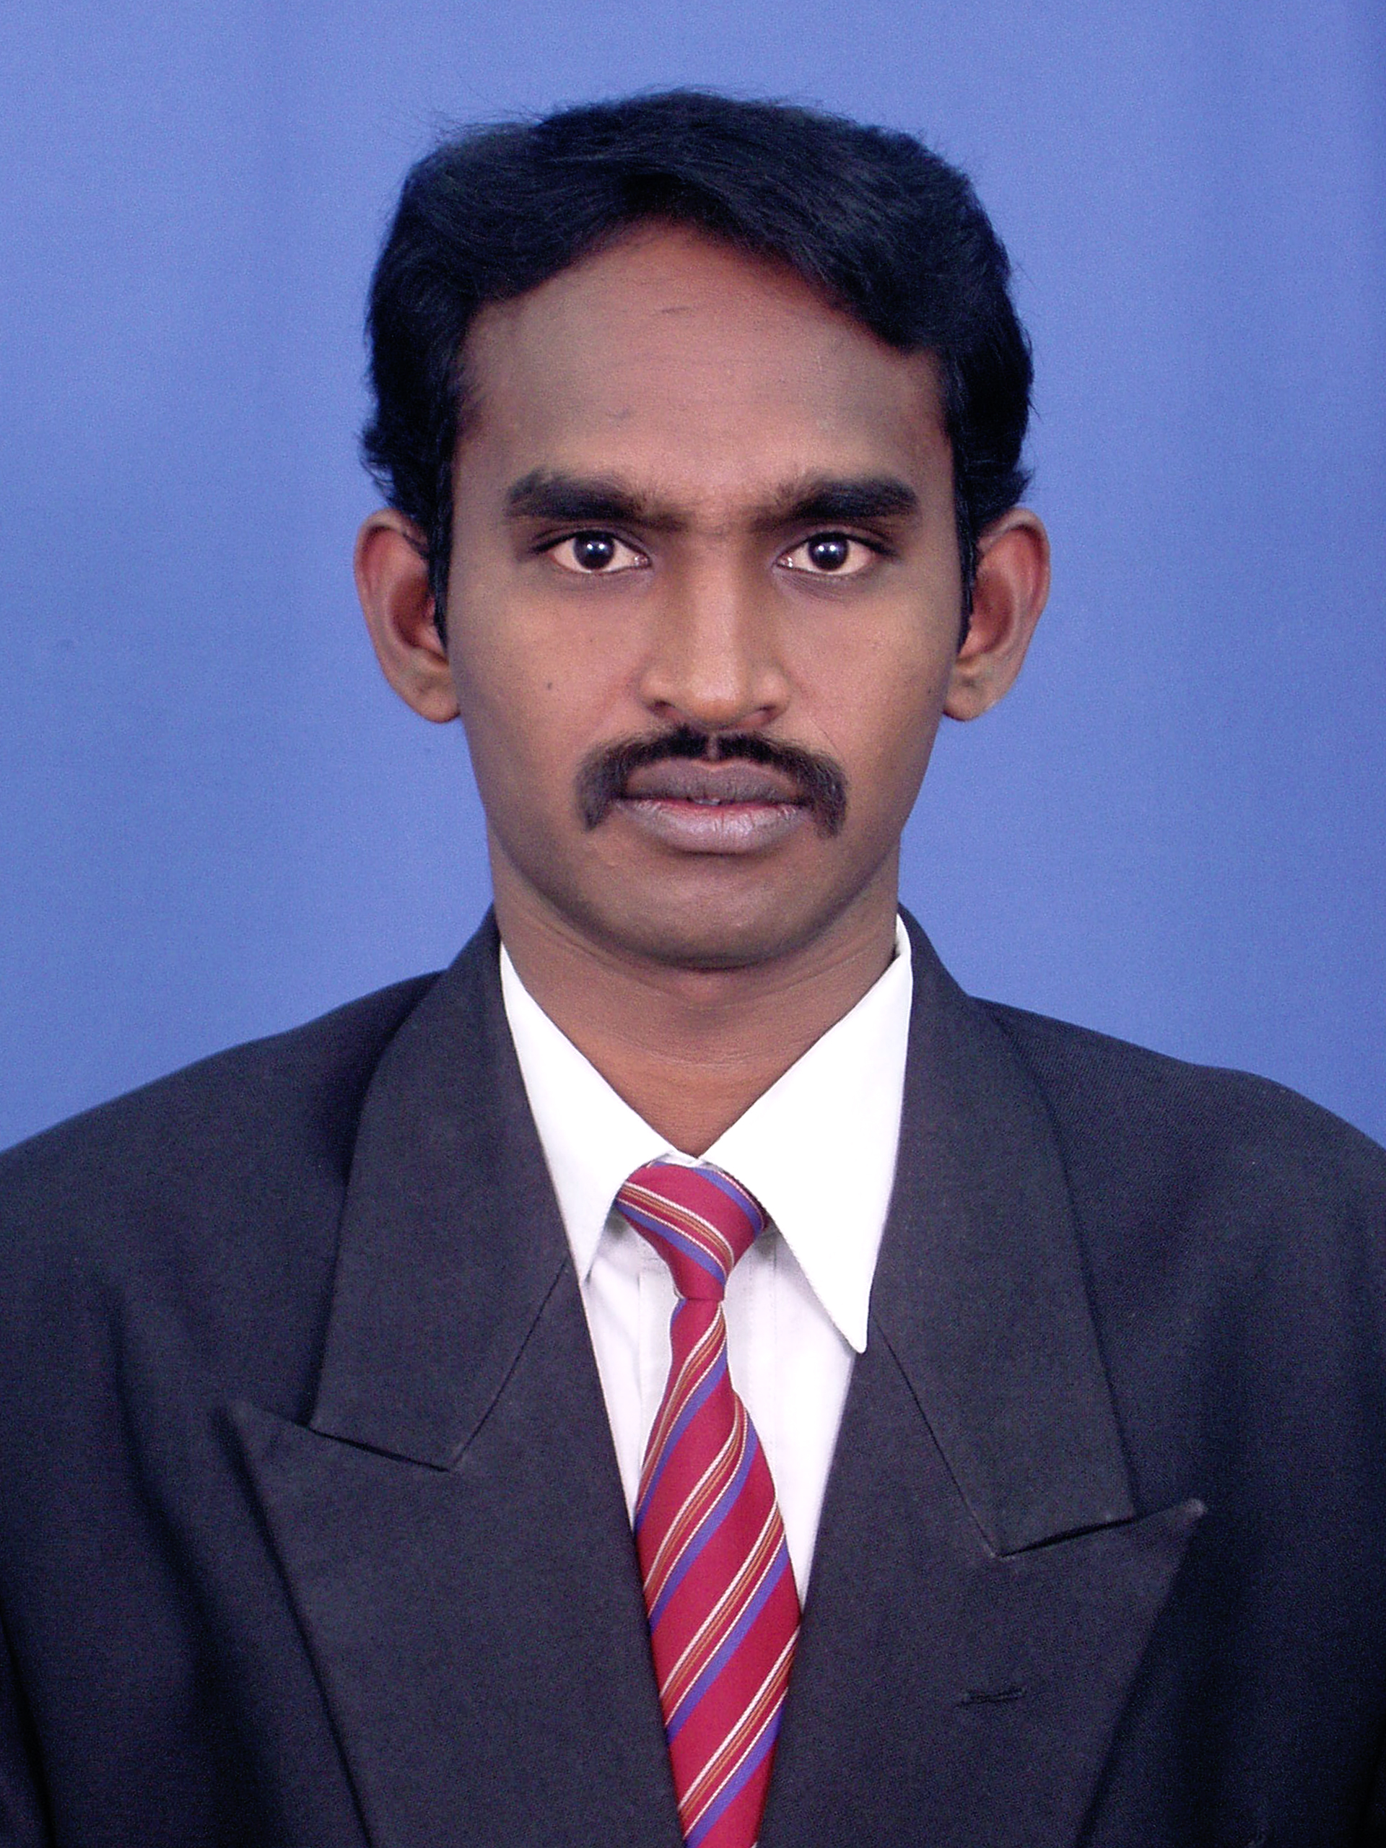
CURRICULUM VITAE OF Dr.A.MUMMOORTHY

Dr.A.MUMMOORTHY
Associate Professor
Department of Computer Science and Engg.,
Malla Reddy College of Engineering & Technology,
Maisammaguda,Dhulapally(post via Kompally)
Secunderabad-500 100,Telangana State,India.
Mobile: +91 9894764884, & 9080008416 E-Mail: amummoorthy@gmail.com

Objective
To be an Engineer where I can contribute my skills and experience to the further development of the institution and achieve growth in my professional career.

Education
Degree | Institution | Specialization
Ph.D | Anna University, Chennai, Tamilnadu,India. | Computer Science and Engineering
M.E | Sri Krishna College of Engineering & Technology,Coimbatore,Tamilnadu,India. | Computer Science and Engineering
B.E | Paavai Engineering College,Namakkal, Tamilnadu,India. | Computer Science and Engineering

Academic Positions:
Position | Institutions | Nature of Work
Associate Professor | Malla Reddy College of Engineering & Technology,Secunderabad | Teaching & Research
Assistant Professor | K.S.R. College of Engineering, Tiruchengode. | Teaching & Research
Lecturer | K.S.R. College of Engineering, Tiruchengode. | Teaching

Professional Experience: Teaching: 11 years & 1 month

Area of Interest:
- Software Engineering
- Computer Networks
Book published
C# programming for beginners ,Dr. A.Mummoorthy & K.Thamariselvi ISBN NO:978-93-87756-40-3
National level award
- I recived the Best academician of the year award awarded by Combined Society for educational Research & Development Dehradun,UK,India.
- I recived the young faculty award awarded by Venus International Faculty Awards-VIFA 2018 India.
Research Publications:
International Journals
- A.Mummoorthy & Suresh Kumar, S “Fragments Signature and Trust Register Technique for Detection of Jammers in Wireless Sensor Networks”KSII Transation On Internet and Information System,Volume 3,Issue 6PP.134-157,December 2011
- A.Mummoorthy, “Energy Efficient and Reducing Delay For data Gathering In Wireless sensor Networks”, International Conference on Advanced Computing ICACT 2012” JKKN College Of Engineering, 9th &10th March 2012.
- A.Mummoorthy, “A Detailed Study on the Evolution of Recent Jammers in Wireless Sensor Networks”, International Journal of Engineering Research and Development, e-ISSN: 2278-067X, p-ISSN: 2278-800X, PP. 12-15, October 2012.
- A.Mummoorthy, “Analysis For Threshold-Based Online Congestion-Aware routing Algorithm ”, International Journal of Communications and Engineering, ISSN No 0988-0382E PP.110-114, Volume 1, Issue 2.pp.60-65,2015, March2012.
- A.Mummoorthy, “Fast Data Collection in Tree-Based Wireless Sensor Networks”, International Journal of Computer Science and Information Technology & Security, ISSN: 2249-9555, PP.1069-1072, December 2012.
- A.Mummoorthy, ”Analysis of Buffer Sizing in Core Routers and Investigating Its Impact on Flow of Files” International Journal of Computer Science and Mobile Computing A Monthly Journal of Computer Science and Information Technology, ISSN 2320–088XIJCSMC, Vol. 2, Issue. 4, April 2013, pg.227.
- A.Mummoorthy,” Detecting Denial of services attacks in wireless network under the distributed jammer network” International journal of Computer Application, Volume-86-No.9, January 2014.
- A.Mummoorthy., “Data Transfers Depends on SAR Protocol Using the Clustered Based Wireless Jammer Network” Australian Journal of Basic and Applied Sciences, page 72-77.June2014
- A.Mummoorthy.,” A New Approach for Gathering Data and Increase the Network Lifetime in Wireless Sensor Networks”, International Journal of Advanced Research in Information and Communication Engineering, ISSN 2321-8762, VOL. 2, Issue 11, November 2014.
- A.Mummoorthy.,” Fuzzy Based Co-Cluster Algorithm for text Clustering”, International Journal of Engineering Technology Science and Research, 2394-3386,Volume 2 Issue 1, Jan2015.
- Pavithra.E and A.Mummoorthy “Improved Methodology for Data Effectiveness in Cloud Computing”International Journal of Mathematical Science and Engineering,Volume 4,Issue 2 ISSN 2278-1447,March 2015.
- A.Mummoorthy & Suresh Kumar, S 2016, ‘Jammer Localization in Wireless Sensor Network Using Percolation and Poisson Process’, Asian journal of information technology, ISSN 1682-3915, vol. 15,no. 14, pp. 2322-2327. May 2016
- A.Mummoorthy & Suresh Kumar, S 2016, ‘Energy Aware Routing Protocol Poisson Process using Diffusion Update Algorithm in Wireless Sensor Networks’, Asian Journal of Research in Social Sciences and Humanities, ISSN 2249-7315, vol. 6, no. 6, pp. 130-147.July 2016
- A.Mummoorthy “Novel Approaches of Biometric finger print minutiae detection and extractions process”International journal of mechanical engineering and Technology, ISSN print:0976-6340 and ISSN online:0976-6359,Vol .8,Issue 12,Decmber2017,PP.469-477.
- A.Mummoorthy“Query Formulation Technique Using of Data Web Mining” Bonfring International Journal of Networking Technologies and Applications, Online ISSN: 2320-5377 | Print ISSN: 2279-0152,Vol.5, March , 2018,PP.05-08
- A.Mummoorthy“Using of Bellman Fords Algorithm in WSN to Identify the Shortest Path and Improve the Battery Power & Control the DDOS Attackers and Monitor the System Environment” Bonfring International Journal of Networking Technologies and Applications, Online ISSN: 2320-5377 | Print ISSN: 2279-0152,Vol.5, March , 2018,PP.09-11.
- A.Mummoorthy“Survey on Optimized communication in Terrestrial wireless sensor network” Taga Journal of graphic technlogy , Online ISSN: 1748-0345 (Online) | Vol.14, 2018,PP. 1899-1905
- A.Mummoorthy“Network Modeling for Distributed DoS Attack Detection using Naive Bayes” Wulfenia journal” , Online ISSN: 1561-882X (Online) | Feb Vol.25, 2018,PP. 02-13
- A.Mummoorthy“Consistent and effective energy utilisation of node model for securing data in wireless sensor networks” International journal of grid and Utilty Computing(Inderscicence Jorunal),Vo1.9,No.3,2018.
Paper Presented at National/International Conference
- Presented paper at International Conference entitled Intelligent Design and Analysis of Engineering Products, Systems and Computation held on 9th and 10th July, 2010 at Sri Krishna College of Engineering and Technology
- Presented paper at International Conference entitled Analysis of Flow Correlation Attacks in Anonymity Networks against Passive Logging Attacks held on 9th and 10th May, 2011 at E.G.S Pillay Engineering College
- Presented paper at National Conference entitled Energy Efficieny and Reducing delay of Data Gathering in Wireless Sensor Networks held on 6th, Mar 2012 at Sengunthar Engineering College.

- Presented paper at International Conference entitled Energy Efficieny and Reducing delay of Data Gathering in Wireless Sensor Networks held on 9th & 10th, Mar 2012 at J.K.K.Natatraja College of Engineering and Technology.
- Presented paper at National Conference entitled Analysis of Buffer Sizing in Core Routers and Investigating Its Impact on Flow of Files held on 23rd, Sep 2013 at Easa College of Engineering and Technology.
- One day National level Workshop on LATEX – A Tutorial Prespective for Effective Journal Writing Conducted by AVS Engineering College, 1st Feb 2014.
- Presented paper at International Conference entitled Detailed Study on the Evolution of Recent Jammers in Wireless Sensor Networks held on 4th & 5th, Mar 2015 at Vivekananda Institute of Engineering and Technology for Women.

- Presented paper at International Conference entitled Fuzzy Based Co-Cluster Algorithm for Text Clustering held on 4th & 5th, Mar 2015 at Vivekananda Institute of Engineering and Technology for Women.

- Presented paper at International Conference entitled Detecting Denial of Services Attacks in Wireless Network under the Distributed Jammer Network held on 4th & 5th, Mar 2015 at Vivekananda Institute of Engineering and Technology for Women.

- Presented paper at International Conference entitled A New Approach for Gathering Data and Increase the Network Lifetime in Wireless Sensor Networks held on 4th & 5th, Mar 2015 at Vivekananda Institute of Engineering and Technology for Women.

- Presented paper at International Conference entitled Fast Data Collection in Tree-Based Wireless Sensor Networks held on 4th & 5th, Mar 2015 at Vivekananda Institute of Engineering and Technology for Women.

- Presented paper at International Conference entitled Adaptive Packet Transmission in Smart Grid to minimize the Message Delay held on 10th & 11th, Mar 2016 at Hindustan College of Engineering and Technology.

- Presented paper at International Conference entitled Jammer Localization in Wireless Sensor Network Using Percolation and Poisson Process held on 30th & 31st , Mar 2016 at Vivekananda Institute of Engineering and Technology for Women.

- Presented paper at International Conference entitled Energy Aware Routing Protocol Poisson Process using Diffusion Update Algorithm in Wireless Sensor Networks held on 30th & 31st, Mar 2016 at Vivekananda Institute of Engineering and Technology for Women.
- Presented paper at International Conference entitled Improving Energy Efficient In Wireless Sensor Networks Using Path Algorithm held on 29th & 30th , November 2017 at Malla Reddy college of engineering.
- Presented paper at International Conference entitled Improving Time Orient Spatial Traffic Pattern Based Mitigation Of Distributed Denial Of Service Attacks With Djn In Distributed Wireless Networks held on 29th & 30th , November 2017 at Malla Reddy college of engineering.

Sponsored Events Organized
- Received an amount of rupees 25,000/-from ISRO for organizing two days National Seminar Soft Computing Techniques in 2017

Pattern
- I applied pattern entitle “Compact Multi-Functional smart laptop” and awiting for approval.(Application No:201841002061 A)
- I applied pattern entitle “An Automated system for assisting person of medical needs” and awiting for approval. (Application No:201841015460 A)
- I applied pattern entitle “Horizontal axis cam guided telescopic blade yaw controlled wind mill” and awiting for approval.

FDP/Workshop/Seminar/Hands on Training Programme/Symposium Organized
- Two days National level Technical Symposium (ABLAZE 2K13) 11th & 12th Sepemtember 2011 at K.S.R.College of Engineering, Tiruchengode.
- One day National level Technical Symposium (ABLAZE 2K13) 11th September 2012 at K.S.R.College of Engineering, Tiruchengode.
- Two days hands on training programme in Wired and Wireless Protocol Design using NS2 on 12th and 13th Sep 2014 at K.S.R.College of Engineering, Tiruchengode.
- One day workshop on “How to write the thesis” on 29th November 2014 at K.S.R.College of Engineering, Tiruchengode.
- One day National level Technical Symposium (ABLAZE 2K13) 11th September 2014 at K.S.R.College of Engineering, Tiruchengode.
- Conducted the hands on training programme in Cloud computing using Microsoft AZURE on 7th Mar , 2015 in K.S.R. College of Engineering, Tiruchengode.
- Organized a National Level Workshop on Multimedia Tools in 2015. in K.S.R. College of Engineering, Tiruchengode.
- Organized a two days National Seminar Soft Computing Techniques in 2017. In K.S.R. College of Engineering, Tiruchengode.
FDP/Workshop/Seminars attended
- Two days Workshop on Distributed Service Models Conducted by Coimbatore Institute of Technology, Sep 3rd & 4th, 2010.
- Three days FDP Conducted by Ma Foi Academy at K.S.R.College of Engineering, Sep 21st to 23rd, 2010.
- 13th ISTE Annual Convention of Tamilnadu and Pondicherry Section on Emerging trends in Engineering Education-Indian Perspective Conducted by K.S.R.College of Engineering, Oct 29th to 30th ,2010

- One day National level Workshop on Cloud Computing and Research Applications Conducted by K.S.R.College of Engineering, Jan 28th, 2011.
- Three Days Workshop on Hardware and Networking Conducted by K.S.R.College of Engineering, Aug 23rd to 25th, 2011.
- Workshop on Wireless Sensor Network for the Surveillance of Nuclear Radiation Conducted by K.S.R.College of Engineering ,June 18th &19th ,2012.
- Two Weeks Seminar on Research Initiatives in data mining for web intelligence Conducted by K.S.R.College of Engineering , June 22nd to 03rd July 2012.
- One day National level Pre-conference Workshop on Cloud Computing Conducted by Easa College of Engineering and Technology, 22nd Feb, 2013.
- Two weeks FDP on Security Issues in Utility Computing Conducted by K.S.R.College of Engineering, May 17th to 30th, 2013.
- ISTE workshop on Database Management Systems conducted by Indian Institute of Technology , Bombay, May 21st to 31st , 2013.
- Three days Seminar on Gene Expression Data Analysis Using Machine Learning and Soft Computing Techniques Conducted by Kongu Engineering College, Sep 6th & 8th ,2013.
- One day Seminar on Challenges and Strategies in Research Conducted by SNS College of Technology, 27th Sep 2013.
- One day Seminar on Wireless sensor networks for the surveillance of nuclear radiation, Conducted by K.S.Rangansamy college of Technology 5th Oct 2013.
- One day Workshop on Way and Means to Write Research Paper Conducted by AVS Engineering College, 7th Dec 2013.
- One day Seminar on Writing Effective Research Paper(s) and Thesis Conducted by K.S.R.College of Engineering , 19th July 2014.
- ICT Academy of Tamilnadu Workshop on Cloud Infrastructure & Services,17th to 21st November 2014
- National level Workshop on Blooms Taxonomy and Assessments Conducted on K.S.R.College of Engineering, 20th Mar 2015.
- ICT Academy of Tamilnadu Workshop on Introduction to C# .Net, 27th to 28th April 2015 held at Vidhyaa Vikas College of Engineering and Technology.
- Attended and completed a ABAP with SAP Net wear Course TAW10 & TAW12(SAP NW 7.0) Certificate obtained via SAP Education’s Site License program
- Two days hands on training on Big Data Analytics using Spark and Scala Conducted by K.S.R.College of Engineering , 26th &27th Sep,2016
- Seven days FDP on Free and Open Source Software Conducted by K.S.R.College of Engineering , 1st to 5th ,19th &20th Dec,2016
- One day Workshop on Designing Website using Word press, Drupal and Joomla Conducted by K. S. Rangasamy Institute of Technology, 30th Dec, 2016
- Two days Workshop on Emerging Trends in Interfacing of Medical Equipment and EMR using Cloud Computing Conducted by KSRIET, 15th & 16th Feb 2017.
Guest Lecturer Delivered
- Delivered a Guest lecture on Digital India programme in K.S.R. Engineering College on 29th Nov, 2015.
- Delivered a Guest lecture on seven days FDP on Software Engineering in N.P.Nachimuthu M.Jaganathan Engineering College on 24th to 30th Nov, 2016.
Proposal details:
- Two days Seminar on Green Computing and E-Waste to Tamilnadu State Council for Science and Technology (TNSCST) on 21st & 22nd Aug, 2015.
- Two days Workshop on Mobile Application Development Using Android Operating System to Tamilnadu State Council for Science and Technology (TNSCST) on 11th & 12th Sep, 2015.
- Two days Seminar on Cloud Computing With Big Data Intelligence to Tamilnadu State Council for Science and Technology (TNSCST) on 25th & 26th Sep, 2015.
- One day National level Workshop on Mutlimedia Tools to Tamilnadu State Council for Science and Technology (TNSCST) on 5th Oct, 2015
- Two days National Level Seminar on Disease Detection using Bio-robotics to the Indian Council for Medical Research (ICMR) on 28th & 29th Jan, 2016.
- Two days Seminar on Soft Computing Techniques in Indian Space Research Organization HQ Department of Space (ISRO) on 4th & 5th Jan, 2017.
- Two days National Level Seminar on Disease Detection using Bio-robotics using Internet of things to the Indian Council for Medical Research (ICMR) on 5th & 6th Decmber 2017.
- Two days National Level workshop on Multiedia Tools to the Indian National Science Academy on 2nd & 3th March 2018 (on Going).
- Two days National Level Seminar on Impact Of Green Computing For Minimizing E-Waste On Human Health to the Indian Space Research Organization HQ Department of Space (ISRO) on 22th & 23th August 2018 (on Going).
Awards& Recognitions
- Award for Achievements in Maximum Proposal for seminar grant to organize conference/faculty development program submitted to funding agencies for 2014-2016 from K.S.R College of Engineering (Autonomous), Tiruchengode.
- Award for Achievements in submitting a highest proposal to organize Academic events for 2016-2017
- Award for Achievements for receiving the highest fund for Academic events for 2016-2017
Research Examiner
- Indian examiner for public voce titled “Hybrid System For Predicting Ivf Success Rate” at Bharathidasan University,Tiruchirappalli- 620 024,India
Membership in academic bodies
- Board of study member in Department of Computer Science and Engineering in K.S.R. College of Engineering, Tiruchengode.
- Board of study member in Department of Computer Science and Engineering in Malla reddy college of engineering and Technology, Secunderabad.
National Advisory Board
- National Advisory Board for ICASETM-17 (International Conference onApplied Sciences, Engineering Technology and Management 2017(ICASETM, to be held at DRK Institute of Science and Technology on November 2nd and 3^{rd,} 2017.

- National Advisory Board for ICRAITSE – 17 (International Conference on Recent Advancements in Information Technology Science and Engineering), to be held at A.P.C. Mahalxmi College for Women, Tuticorin, Tamilnadu onDecember 14th and 15th ,2017.

- National Advisory Board for ICASET-18 (International Conference on Applied Science Engineering and Technology), to be held at Sengunthar College of Engineering, Thiruchengode on 16th – 17th March 2018.

Membership in professional bodies
- Indian Society for Technical Education (LM74417).
- senior member of the International Economics Development Research Center(IEDRC) Member NO.: 30080415
- Associate Member(UACEE) of Institute of Research Engineers and Doctors,Membership No AM10100058480
- Institute For Engineering Research and Publication IFERP Membership No:17006923 & Journal & Conference Reviewer
- International Association of Engineers (IAENG) Member Number:192298
- Computer Science Teachers Association(CSteachers.Org) Membership No:#: 51672714
- InternationalEconomicsDevelopmentResearchCenter(IEDRC)
Membership No: : 30080415

Question Paper Setter
University examination question paper setter for
- Sri krishana college of engineering & Technology,Coimbatore,Tamil Nadu.
- Bannari amman institute of technology, erode, tamil nadu.
- PSG college of arts & Science, Coimbatore,Tamil Nadu.
- SNS college of Technology, Coimbatore,Tamil Nadu.
- Sethu institute of technology, Virudhunager, Tamil Nadu. & chief examiner
Achievements
- Produce 100 percentage results in various subjects in various academic year
- Software Quality Management (2011-2012)
- Web Technology (2012-2013)
- Grid Computing (2012-2013)
- Wireless Sensor Network (2012-2013)
- Object Oriented Analysis and Design (2014-2015)
- Distributed Computing P.G (2015-2016)
- Software Testing and Quality Assurance P.G (2015-2016)
- Distributed Computing U.G (2015-2016)
- Software Testing and Quality Assurance U.G (2015-2016)
- Problem Solving using C U.G (2016-2017)
- Digital Fundamentals and Computer Organization (2016-2017)

Other Academic Responsibilities:
- Association coordinator
- ISO internal auditor
- BOS member
- Academic coordinator
- R &D Incharge
- Yoga Coordinator
- NBA criteria coordinator
- NAAC criteria coordinator
- Sports Co-coordinator
- Infrastrcutre Incharge
- Value added course incharge

Personal details
DoB : 19.06.1983.
Citizenship : Indian
Marital status : Married
Language known : English and Tamil
Address : 120/2, Senthamil Nagar,
Grace School (Opp),
Kaikatti valasu,
Villarasam Patti, (P.O),
Erode-638 107
Tamilnadu
India.
Signature
(Dr.A.Mummoorthy)

